**CODE FOR MATCHES TABLE:**

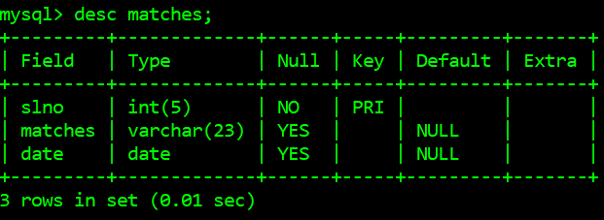

* Create table matches

(

slno int(5) not null primary key,

matches varchar(23),

date date

);

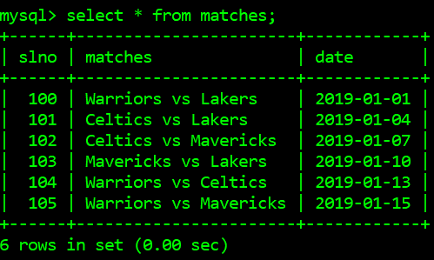

Insert into matches values(100,”Warriors vs Lakers”,”2019-01-01”);

Insert into matches values(101,”Celticsvs Lakers”,”2019-01-04”);

Insert into matches values(102,”Celtics vs Mavericks”,”2019-01-07”);

Insert into matches values(103,”Mavericksvs Lakers”,”2019-01-01”);

Insert into matches values(104,”Warriors vsCeltics”,”2019-01-01”);

Insert into matches values(105,”Warriors vsMavericks”,”2019-01-01”);

**CODE FOR FLIGHT TABLE:**

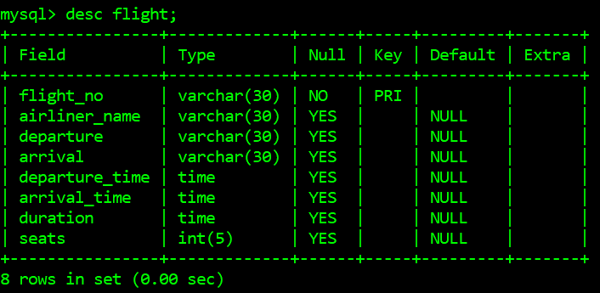

mysql> create table flight

(

flight_no varchar(30) not null unique,

airliner_name varchar(30) not null,

departure varchar(30),

arrival varchar(30),

departure_time time,

arrival_time time,

duration time,

seatsint(5)

);

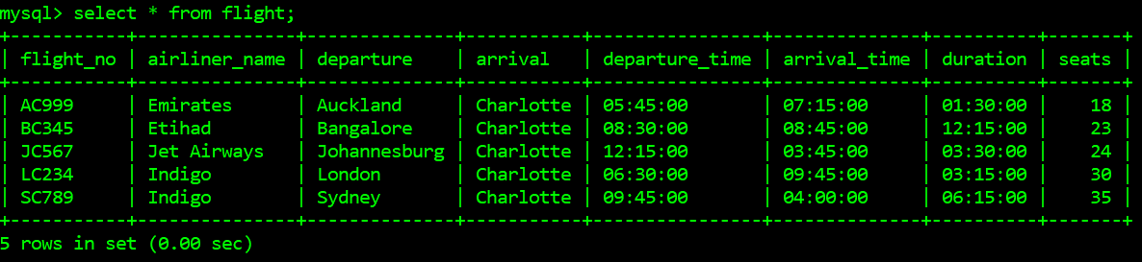

insert into flight values("LC234","Indigo","London","Charlotte","06:30:00","09:45:00","03:15:00",30);

insert into flight values("BC345","Etihad","Bangalore","Charlotte","08:30:00","08:45:00","12:15:00",23);

insert into flight values("AC999","Emirates","Auckland","Charlotte","05:45:00","07:15:00","01:30:00",18);

insert into flight values("JC567","Jet Airways","Johannesburg","Charlotte","12:15:00","03:45:00","03:30:00",24);

insert into flight values("SC789","Indigo","Sydney","Charlotte","09:45:00","04:00:00","06:15:00",35);

**CODE FOR USER TABLE:**

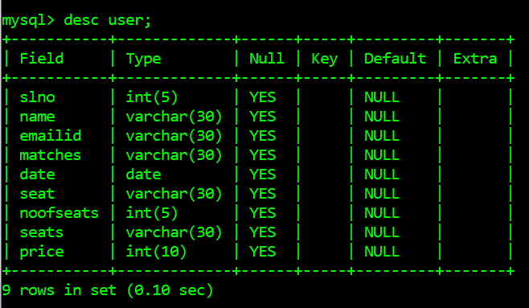

Create table user

(

slno int(5),

name varchar(30),

emailid varchar(30),

matches varchar(30),

date date,

seat varchar(30),

noofseats int(5),

seats varchar(30)

price int(10)

);

Insert into user values(100,null,null,null,null,null,null,null,null);

*// Values are updated during run time of project.*

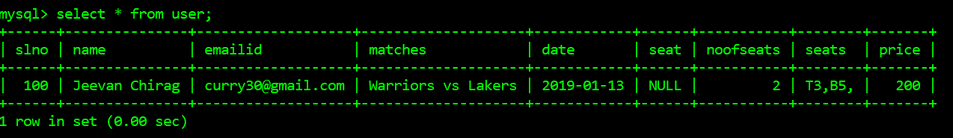

**CODE FOR AIR TABLE:-**

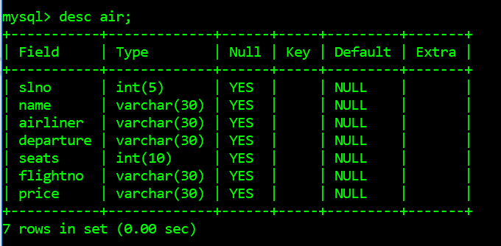

Create table air

(

slno int(5),

name varchar(30),

airliner varchar(30),

departure varchar(30),

seats int(10),

flightno varchar(30),

price varchar(30)

);

Insert into airvalues(100,null,null,null,null,null,null);

*// Values are updated during run time of project.*